USING THE CONCEPT5 EQUIVALENT INGREDIENT FEATURE

The Equivalent Ingredient feature allows a product to be saved as an ingredient.
To maintain accuracy, the system requires the ingredient to reference a plant/product
combination, and the plant/product to reference the ingredient. Once the link is
established, the system automatically updates the nutrient profile and price
of the ingredient each time a Save request is made for the product.

The feature requires two steps: setting up the ingredient, and then setting up the product. In this example, we will formulate a vitamin premix and link it to a new ingredient that we will create. We will start the process by building the ingredient.

Click the Ingredient Maintenance button on the main menu to open the Base Ingredient Maintenance screen.

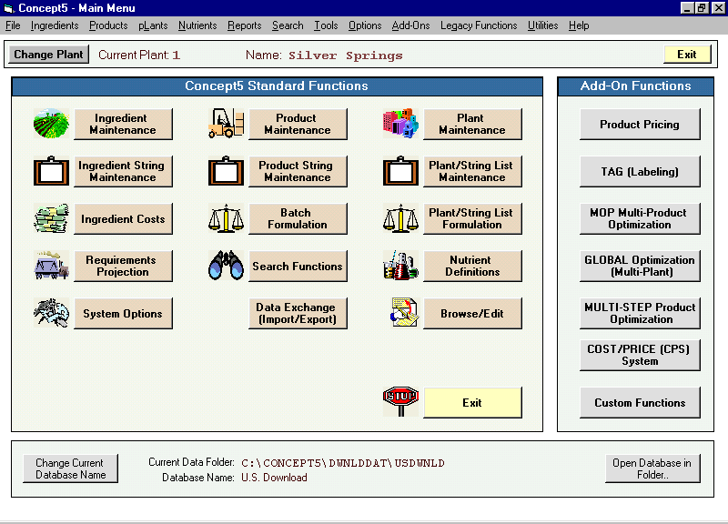

The ingredient maintenance screen will open to the first ingredient. Because we are going to create a new ingredient, it doesn’t make any difference what ingredient is showing on the screen. Click the Add New Ingredient button to open the Adding Ingredient popup.

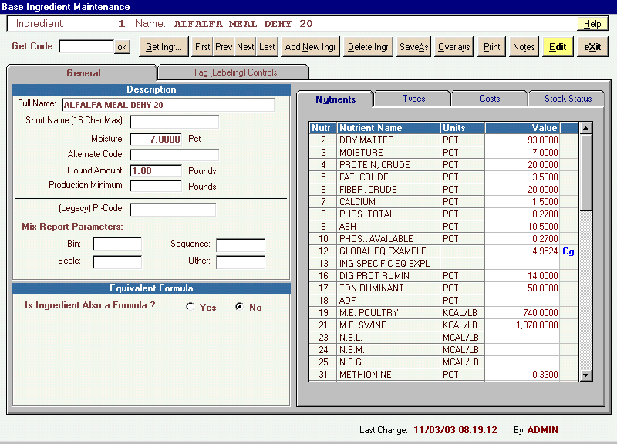

Enter the code number of the new ingredient in the textbox of the popup. This alphanumeric code may be from one to eight characters long.

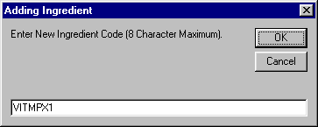

Our new ingredient was assigned code, VITMPX1. Click the OK button on the popup.
The Base Ingredient Maintenance screen will return showing only the code number just assigned, and the screen will be in the edit mode. Click in the Full Name textbox and type in a name for the ingredient. We named the new ingredient VITAMIN PREMIX 1.

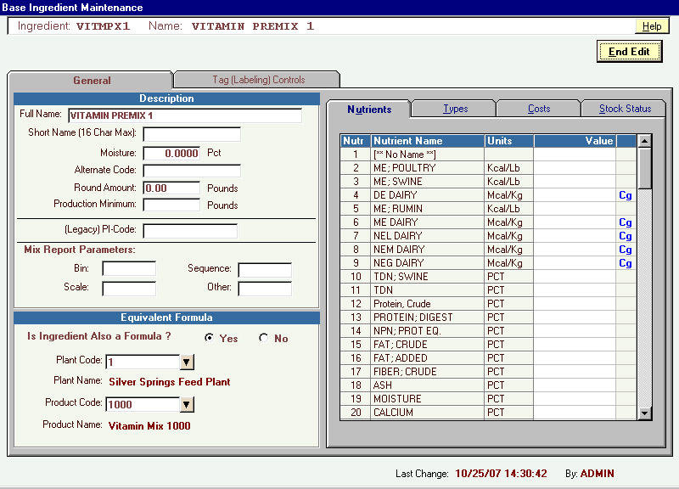

To link the ingredient to a product, select the Yes option in the Equivalent Formula frame, and then select the Plant and Product to which the ingredient will be linked. Use the arrow buttons to assist in the selection. In our example, this ingredient will be linked to product 1000, at plant 1, Silver Springs Feed Plant. (The Product Name will not be showing if it has not yet been created.)

Click the End Edit button, then Yes to the Save Changes popup, then the Exit button to return to the main menu.

Now all that remains is to link the product (code 1000 at plant 1) to the ingredient we just built.

From the main menu, click the Product Maintenance button to open the Product Maintenance screen, and select product code 1000.

The following shows the Product Maintenance screen for product code 1000, and is in the edit mode.

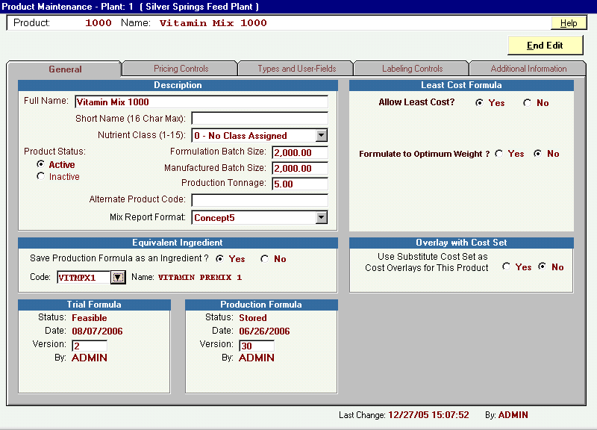

To link this product to ingredient code, VITMPX1, select the Yes option in the Equivalent Ingredient frame and then enter the ingredient code in the textbox. Click on the arrow button to open the ingredient menu for assistance.

Click the End Edit button and select Yes to the Save Changes popup that appears.

Because product Vitamin Mix 1000 was built in the Buffered Least Cost Formulation screen, we will activate the ingredient from that screen. Click the Full Screen Formulation button to open the buffered screen.

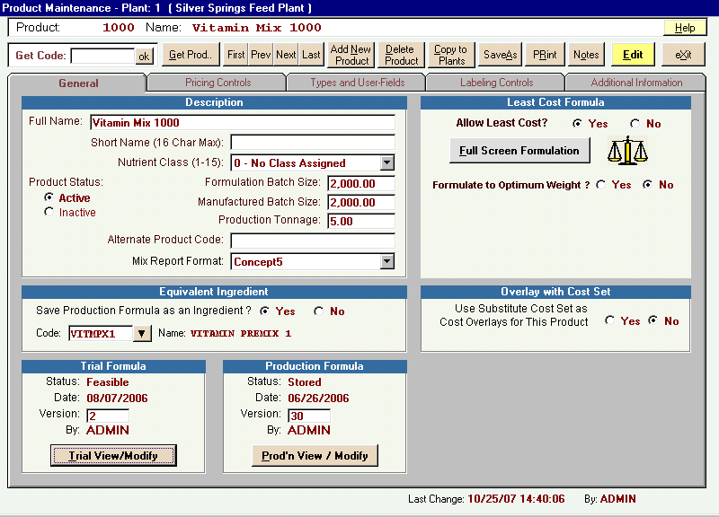

On the Buffered screen, click the Save button.

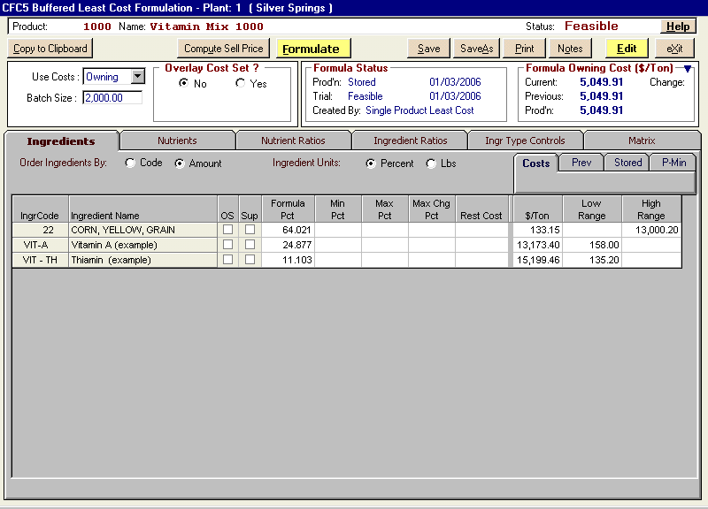

The following popup will appear offering several options to the save request. Note that the second-last option is to update Equivalent Ingredient VITMPX1. In this example we will select all the options shown. Then click the Save button. The ingredient is now updated with the nutrient profile and cost of product 1000.

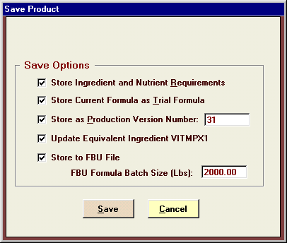

Following is the screen shot from the Base Ingredient Maintenance screen for ingredient code VITMPX1. Note that the nutrient tab is now showing nutrient values.

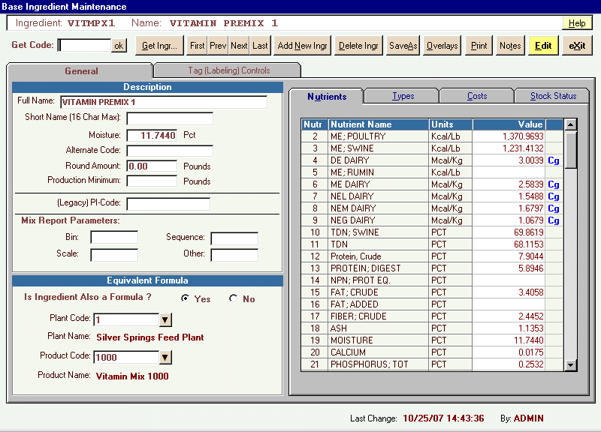

The procedure is now complete. Hereafter, each time the product is saved, a popup will prompt you with the option to update the equivalent ingredient tied to the product.

For more information, select Help from the menu bar on the main menu, then Concept5 Help from the drop down menu. From the Contents tab of Help, double-click Ingredients to open the topic selections, and then click on Equivalent Ingredient to view the topic.

